Towson University Unit-Level Assessment Guidelines

Assessment of administrative units is a responsibility of the Office of the President. The process is designed to roll-up the assessment results from the unit level through the division level to the institutional level for reporting purposes. A common assessment template is used and results are posted on an annual basis after review at the unit level. The process is designed to benefit the unit, allowing for identification of outcomes and measures that are most useful to the unit, rather than outcomes and measures common to the divisions and the units. As data are collected and reviewed, the unit develops strategies for improvement based on unit level requirements. This decentralized process is a hallmark of the Towson University assessment processes.
Assessment templates are maintained in the Compliance Assist site. The planning phase involves creation and approval of an “Overview” template at the start of the assessment cycle (Attachment A). The reporting phase occurs annually and includes collection, analysis, and identification of improvement strategies based on that analysis use the annual “Outcome Results” reporting template (Attachment B). The results of the prior year’s activities are due in Compliance Assist on the first business day of November. These reports are reviewed within the administrative structures and are finalized in early January. Assessment activities are reported in Compliance Assist according to the assessment schedule (Attachment 3).
The annual reporting process included a peer review critique in the spring during Assessment Day. The rubric is designed to give users a sense of where they are in the development of a robust assessment process (Attachment D). For each of these areas, peers rate the assessment activities according to the following rubrics: Best Practice, Meets Expectations, Beginning, or Not Able to Rate. These ratings, along with qualitative feedback, are designed to assure that assessment units demonstrate continuous improvement in student learning and/or planning. Assessment Day is also an important opportunity to share experiences and examine assessment processes across the campus. Administrative units and programs present their information on an annual basis.
Assessment is a process that occurs over an extended period of time (the assessment cycle). The assessment cycle is linked to the strategic planning process and is currently set as a five-year cycle. The process includes five key elements that are included in the assessment template for each unit:
- Create the mission of the unit, identifying primary functions, and stakeholders
- Establish objectives and strategies based on efficiency, productivity, and impact on stakeholders
- Identify assessment processes
- Report assessment results or areas for improvement based on data
- Develop improvement strategies based on analyses of data
Elements 1-3 are part of the planning phase. Once these are approved, the second phase of assessment begins – the reporting and improvement phase which includes elements 4 and 5. Reporting occurs throughout the assessment cycle with the submission of annual updates. Divisional assessment committees review these reports to ensure ongoing assessment and determine the efficiency and effectiveness of units in the division in meeting divisional and institutional plans.
Planning Phase
The planning phase involves identification of unit goals, objectives/outcomes, and identification of the processes used to assess the measures. Once identified, these elements are posted on the assessment template in Compliance Assist. Steps involved in this phase include:

Each unit develops a mission statement developed within the context of divisional and institutional expectations. It includes identification of key stakeholders of unit services.

Each unit identifies two or three key unit-level goals related to divisional/institutional goals.

The goals of administrative and educational support units should be aligned to the goals of the institution. Goals are broader/general assertions that describe the overarching long-term intended objectives of the unit. Goals may or may not be measurable and usually need to be further developed as separate/distinct objectives, that, when measured appropriately, provide evidence of the unit is accomplishing its goals.

Example of a goal (administrative unit):
“To improve TU’s student learning assessment process”

Example of a goal (educational support unit):
“To provide leadership skills to students and student leaders”

- Each unit defines at least one intended objective/outcome for each unit-level goal. Each objective/outcome should include a targeted threshold to be achieved by the end of the five- year period (assessment cycle) as well as several strategies designed to achieve the objective/outcome.

Objectives (Administrative Units) Objectives are measurable statements that describe the expected or intended quality relative to timeliness, responsiveness, accuracy, etc. Objectives often describe how well a unit intends to function or improve its functioning or the services provided. The important question in this section is: “What is the office trying to accomplish?” Client satisfaction is the most common type of administrative outcome/objective. Less common, but equally acceptable administrative outcomes/objectives are those that focus on the abilities of clients once services have been provided (e.g., staff’s ability to process a requisition after training has been provided).

Administrative-level objectives must be:
- Linked to the university goals and mission statement
- Realistic in terms of the resources and support currently available within the unit
- Measurable – feasible to collect accurate quantitative and/or qualitative data usable for making improvements to process or unit

Example of administrative objective:
“Expand use of purchasing cards (P-Card) for commodities and services utilized by the university”

Student Learning Outcomes (Educational Support Units) Student learning outcomes are statements that target the intended knowledge, abilities, values and attitudes students are meant to be able to demonstrate after participating in a given activity and/or after using services within an educational support unit. Student learning outcomes must be specific to the unit and measurable.

Example of a student learning outcome:
“Students participating in Learning Communities will express higher levels of personal interaction and satisfaction with the learning environment in the residence halls than other resident students”

- Each unit identifies two different measures and performance targets related to each objective/outcome.

Measures refer to the methods used by the unit to assess the unit’s success in reaching its objectives, (e.g. surveys, focus groups). “Performance Targets” refer to how the unit defines success based on the defined objectives. It is important that the methods chosen enable the unit to evaluate its effectiveness in terms of services offered. Multiple measures (at least two) must be identified that will be collected to determine the achievement of each objective/outcome during the review period. Data must be collected at least twice for each measure during the assessment cycle and some data and analysis must occur annually. A primary objective of assessment is to illuminate strengths and weaknesses in the unit to lead to improvement.

Examples of Measure and Performance Target (Administrative Units):
“Comparison of this year’s spending with last year’s spending”
“Customer satisfaction survey will indicate that more than 80% (15% more than last year) of respondents are satisfied with our services”

Examples of Measure and Performance Target (Educational Support Units):
“Students participating in the Freshman Orientation program will complete the summary test and score a mean of 5.5 or above on all questions.”
“At least 75% of students responding to the Tunnel of Oppression survey will indicate that the experience changed their thinking about oppression.”

Unit Goals | Relationship to Institutional/Divisional Goals | Objectives/Outcomes With Five Year Performance Targets | Measure 1 (Collection Cycle) | Measure 2 (Collection Cycle)
Goal 1 |  | 1.1
 |  | 1.2
Goal 2 |  | 2.1
 |  | 2.2
Goal 3 |  | 3.1
 |  | 3.2

Reporting and Improvement Phase

The elements of the reporting and improvement phase involve the following steps:

- Collect data using the measures described above according to the collection cycle identified. Post results on the assessment template under Annual Summary of Data in Compliance Assist.

- Analyze the results, share findings with appropriate stakeholders, and identify improvement strategies designed to address assessment results. The analysis should reflect data-driven decision making. Post a summary of this analysis in the assessment template in Compliance Assist.

The Towson University process is based on methods used by the University of Central Florida (pulled June 28, 2012) and the University of Southern Florida (pulled June 30, 2012).

Attachment A - Planning Template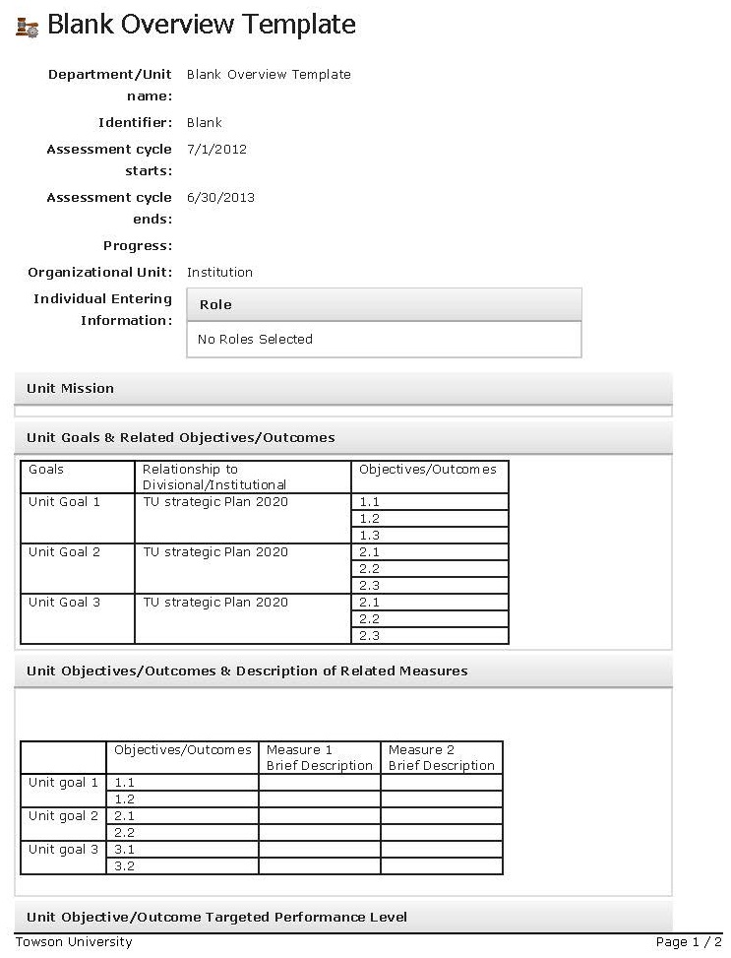
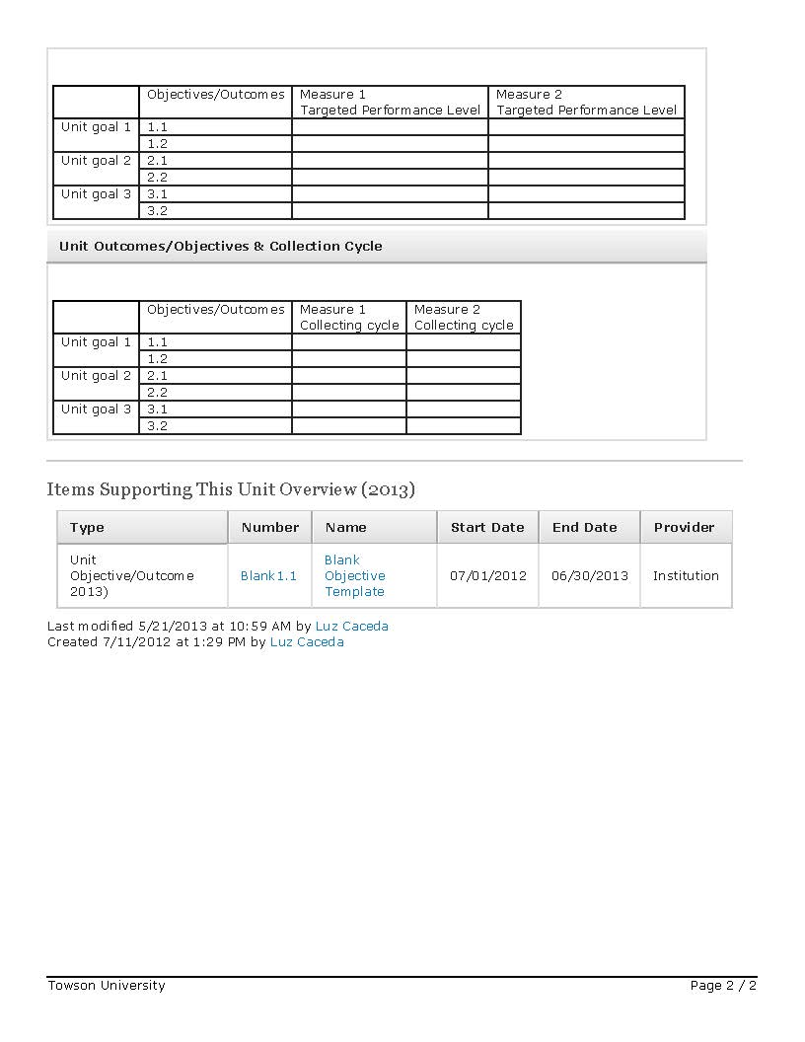

Attachment B – Objective Reporting Template
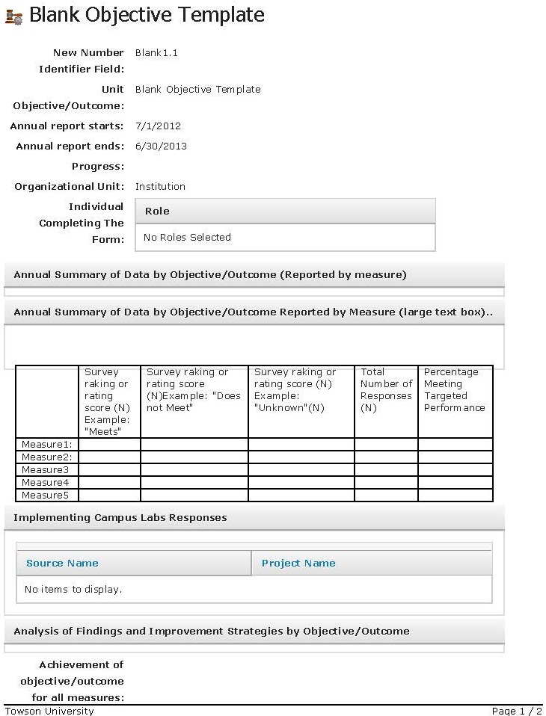
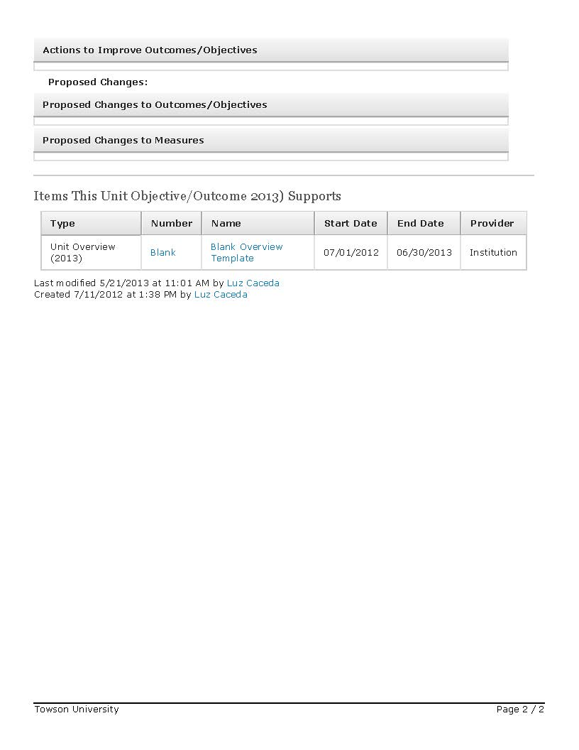

Attachment C - Assessment Schedule and Sample 2-Year Cycle
Cycle | Task | Task Description | Responsible Party | Date
1 | Overview Updates Finalized in CA | Updates to Overview for next collection cycle finalized in Compliance Assist (CA). | Program/Dept/ Unit | 6/30/2016
1 | Data Collection and Analysis Phase | Collection of data and analysis of results. | Program/Dept/ Unit | 7/1/16-6/30/17
1 | Reporting Phase in CA | Report data and improvement strategies using Report Templates in CA. Share results with key constituents. Submit for next level review and select "Ready for Review" in CA. | Program/Dept/ Unit | 7/1/17-10/31/17
1 | Review Phase | Next level review by appropriate office. Once Reports finalized, select "Final" in CA. | Deans/Division Coordinator | 11/1/17-12/31/17
1 | Peer Review | Review data and results by assessment peers. | Assessment Peers | 1/1/18-1/31/18
2 | Overview Updates Finalized in CA | Updates to Overview for next collection cycle finalized in CA. | Program/Dept/ Unit | 6/30/2017
2 | Data Collection and Analysis | Collection of data and analysis of results. | Program/Dept/ Unit | 7/1/17-6/30/18
2 | Reporting Phase in CA | Report data and improvement strategies using Report Templates in CA. Share results with key constituents. Submit for next level review and select "Ready for Review" in CA. | Program/Dept/ Unit | 7/1/18-10/31/18
2 | Review Phase | Next level review by appropriate office. Once Reports finalized, select "Final" in CA. | Deans/Division Coordinator | 11/1/18-12/31/18
2 | Peer Review | Review data and results by assessment peers. | Assessment Peers | 1/1/19-1/31/19

The following page includes a depiction of two assessment cycles.
Attachment D - TU Assessment Cycle -Schedule of Responsibilities 2015-2016

Attachment E

Peer Review Feedback Form for Annual Assessment Reports and Presentations
Unit: | Report Year:

 | Not Able to Rate (NR) |  | Beginning |  | Meets Expectations |  | Best Practice |  | Overall  Rating
Unit Objectives | Not Able to Rate |  | Unit objectives have been identified. |  | Unit objectives are measurable. |  | Unit objectives routinely shared with staff/faculty.
Assessment Measures | Not Able to Rate |  | General measures of unit objectives are identified. |  | At least two specific measures of approved unit objectives are identified with one being a direct measure. |  | At least two direct measures are used to assess each unit objective.
 |  |  |  |  | Rubrics are provided for each measure.
 |  |  |  |  | Data collection for at least one measure occurs annually.
Assessment Results | Not Able to Rate |  | Collected data are aggregated for at least one of the unit objectives annually. |  | Collected data are aggregated for a majority of the unit objectives annually. |  | Aggregated data are analyzed in a systematic manner to evaluate prior actions to improve unit activities.
 |  |  |  |  | A schedule is established to measure/collect data on all unit objectives within a six-year timeframe.
 |  |  |  |  | Collected and aggregated data are linked to specific unit objectives.
Analysis by Unit  14 | Not Able to Rate |  | Assessment coordinator/leader and department chair received annual assessment results. |  | Relevant staff/faculty received annual assessment results. |  | Staff/faculty synthesized results from multiple measures to form specific conclusions about assessment of unit objectives.
 |  |  |  |  | Relevant staff/faculty met to discuss assessment results in depth.
 |  |  |  |  | Specific conclusions about unit activity made based on assessment results.
Actions to Improve Unit Operations | Not Able to Rate |  | At least one issue involving assessment of unit objectives identified but no action was yet taken. |  | At least one action is identified to improve unit operations. |  | Description of specific actions and assessment methods for improvement of unit operations that are based on analysis of actions for improvement defined in previous years.
 |  |  |  |  | Description of specific action(s) to improve unit operations that relate directly to conclusions about areas for improvement.
 |  |  |  |  | Description of specific action(s) to improve unit operations including a timetable for implementation
 |  |  |  |  | Identification of individual responsible for each action to improve unit operations.
Comment: _________________________________________________________________________________________________________________ ____________________
__________________________________________________________________________________________________________________________ ____________________ _________________________________________________________________________________________________________________________ _____________________

The peer review process uses a descriptive rubric with four levels to scale specific criteria in the assessment process. The scale includes “Beginning,” “Meets Expectations,” “Best Practices,”, and “Not Able to Rate.” The scale values are listed horizontally on the form. Raters evaluate five criteria of the assessment activity: “Unit Objectives,” “Assessment Measures,” “Assessment Results,” “Analysis by Unit,” and “Actions to Improve Unit Operations.” The criteria are listed vertically in the left hand column. Descriptors for minimal acceptable rating in each level are included next to criteria.

Use the feedback form as a matrix, working from left to right. Check the descriptors to identify what has been satisfied. The last column on the right “Overall Rating” serves to provide the overall rating for the criteria making sure that all descriptors in the prior level have been achieved. To achieve a rating value, all the descriptors listed under each rating value must be satisfied. If some, but not all of the descriptors are satisfied, then the overall rating for that criteria should be the prior value.

The comment section should be used if the descriptors are not sufficient to justify the rating values or if the reviewers would like to make a suggestion for improvement that needs to be recorded.

Glossary
Assessment Cycle: The timeframe associated with achieving the expected outcomes. The cycle for the current process is five-years.
Assessment Year: Data collection period (April 1-March 31)
Assessment Template: Report format in Compliance Assist that summarizes the elements of assessment associated with the unit.
Compliance Assist: Electronic reporting tool for assessment purposes. Access is password protected. The link is located on the Office of Assessment website at: http://www.towson.edu/assessment/index.asp User should link on “TU Compliance-Assist” under “Announcements.” The username and password are your TU credentials.
Goals: Key functions of the administrative unit aligned with the expectations of the institution/division.
Measures: Measures are the approaches used to conduct the assessment of the unit in achieving each objective. Collection and analysis of assessment data must occur annually. However, not all measures need to be collected each year. The collection timetable should be identified for each measure.
Objectives/outcomes: Specific statements that reflect the broader goals. Objectives for an administrative unit focus more on process and student development, than student learning. They focus on what the user of the unit should be able to know and do as a result of the services offered by the unit. These may include students and other key stakeholders (faculty, alumni, parents, employers, etc. depending on the unit). Objectives also include performance criteria – what standards are expected from services provided by the unit. These provide the basis of the assessment.
Unit: The organizational level identified for assessment purposes. Towson University has identified those organizational structures reporting to the division heads for the purposes of assessment reporting. Division heads may choose to subdivide the organizational tree below that level if they so desire, but baseline unit level information must be collected for all units reporting to the Vice Presidents of each division.

