Stratus Financials
A Guide to Budgeting

Contents
Towson University’s Chart of Accounts 2
Cost Center 2
Account 3
Source 3
Initiative 3
University Objective 3
Budgeting 4
Cost Center Budget Allocations 4
Preparing Your Budget 5
Objects 5
The Importance of Planned Budgeting 5
Guideline for Preparing a Budget 6
Transferring Funds 7
Contact Information 8

Stratus is the financial system that Towson University utilizes for budget, accounting, accounts payable and procurement. STRATUS provides online, up-to-the-minute access to your data. The system can be accessed from anywhere internet access is available.

Towson University’s Chart of Accounts

Cost Center
In Stratus, a five-digit code known as a cost center is used to represent university cost centers and programs. This number is used to establish and set up a budget and track expenses and encumbrances. There are five main types of cost centers in Stratus, as listed below.
- State Support – State Support cost centers are cost centers that are funded by state appropriations.
- Self-Support – These are cost centers that are solely funded by self-generated revenues; they do not receive any state appropriations. Remaining balances (revenue minus expense) are rolled into the cost center’s fund balance.
- Auxiliary – Auxiliary cost centers and activities provide services or goods to students, faculty or staff and charge a fee directly related to the goods or services. These cost centers are essentially self-supporting activities.
- Grant/Project Funded – Grant/Project-Funded cost centers represent programs/projects that receive funds from state, federal or local government agencies. Once awarded, these funds are distributed and managed by the division in which they fall.
- Agency Funded– Agency-Funded cost centers are supported by funds that are deposited on behalf of faculty, staff and student organizations and are used for university-affiliated activities. The individuals in charge of the activity are solely responsible for the management of these funds and any deficit encountered. Towson University is not responsible for covering any overdrawn balances.
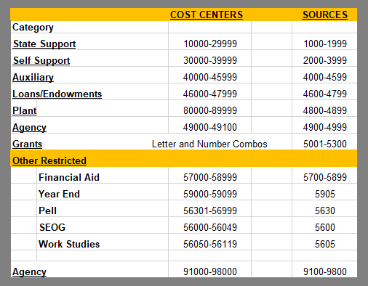

Account
In Stratus, an account is a six-digit code used to define revenues/expenses into more detailed categories. Budgets are loaded at the account (child) level. There is also a parent account, or summary, that groups associated accounts. Budget checking is done at the parent level.

Source
A source is a four-digit code used to track cash balances, essentially a balance sheet. The source allows Self Support and Auxiliary cost centers to track cumulative cash balances, or the cash balance from the inception of the cost center. There are many Self Support and Auxiliary that have a one-to-one relationship between source and cost center. There can also be multiple cost centers that roll up to one source. Cost centers that are not State Support can carry over their remaining funds (revenue minus expenses) at the end of a fiscal year. The chartfield source is used to track those balances from the beginning of the cost center. While the fund balance remains with the cost center, it is not available to use without prior approval from the Vice President of Administration and Finance. Cost centers who wish to request use of their prior year fund balance should work with their Divisional Budget Officer.

Initiative
An initiative is a five-digit code that allows for the use of an additional chartfield further classifying activities into detailed categories. This enables the user to track related expenses for a specific activity within a cost center budget and across cost centers. The initiative chartfield acts as a shadow system within Stratus. An initiative has been defined the same as a project but cannot be used for things that must be capitalized. Cost centers have the flexibility to determine what they want to track as an Initiative. This is not a required chartfield. To track the initiative, the associated value must be present on the transaction. For expenses that come through from outside sources (i.e., payroll, telecommunications, and postage) a journal reclassification would be needed to add the initiative to the associated expense. Cost centers can request to have a specific Initiative established with a 5-character limit. Requests can be emailed to mailto:Stratusfinancialsteam@towson.edu. A description of the Initiative is required.

University Objective
A University Objective is a three-digit code used to track specific revenues and expenses of university-wide activities. The University Objective may be related to strategic goals, or other University-wide Initiatives.

Budgeting
Your budget is the spending limit that has been established for your cost center for the fiscal year, which extends from July 1 to June 30 of a given calendar year. Each division has a budget officer who supplies the University Budget Office with the Division’s budget plan for the fiscal year.

Cost Center Budget Allocations
The estimated timeline for budget allocations is provided below. Please note that changes by the State of Maryland may alter the timeline.
October
The Operating Budget and Plan book is published for the current fiscal year.
November – December
The budget and operating plan guidance letter is sent from the Vice President for Administration and Finance to each divisional area stating general and specific guidelines for the upcoming fiscal year. Budget Submission Instructions are sent to the Divisional Budget Officer (DBO) outlining when documents are due.
November – January
Each division prepares a consolidated resource plan and allocation based upon the cost center budget plans. Cost center plans, including new initiatives, are submitted to the vice president on the Resource Plan and Allocation Form. The divisional budget plan is submitted, with new initiatives in priority order, on the Divisional Resource Plan and Allocation Form to the Budget Office by the end of January.
Base budgets remain the same until changed in the budget approval process. The annual divisional operating plan includes budget reallocations, requests for new resources, personnel changes, position reallocations and requests for new positions. Descriptions of new programs and changes in programs are included.
January – February
The University Budget Office completes the Tuition and Fee Modeling for the next fiscal year based on enrollment projections and USM guidelines. The divisions submit, for university approval, the plans for rates and fees for the upcoming academic year. For example, in February 2022, divisions submitted rate and fee plans for fiscal year 2023 (the fall 2022/spring 2023 academic year).
March - April
Formal internal budget hearings with the president and vice presidents are held with each division presenting their requests for resources previously submitted in the divisional budget request.
April
External budget decisions are finalized by the General Assembly and USM. The campus is notified of any changes from the external budget submission that may impact the internal allocation.
June
The Budget Office, in cooperation with divisional budget officers, loads detailed cost center budgets to the automated system for the July 1 fiscal year start.

Preparing Your Budget
You will need to have a budget plan to detail your expenses throughout the fiscal year. Budget balances are not carried over from the previous fiscal year. If you have an open commitment on your cost center at the end of a fiscal year, it is automatically carried over to the next fiscal year.
The budgets of Self Support and Auxiliary areas should be based on the target revenue for that fiscal year. Please note that the use of your prior year fund balance must be approved in advance by the Vice President of Administration and Finance. You will need to work with your Divisional Budget Officer to submit this request.
One of the easiest ways to prepare your budget is to look at your budget and expenses from the prior fiscal year to determine the amount of funding that you will need to operate this fiscal year. You will want to see if you have any new contractual employees, if any salary increases were given, the number of students working, and any out of the ordinary purchases you need to make that fiscal year (i.e. new PC’s or other special equipment). If starting a new cost center, the same guidelines apply. Look at each account to determine what expenses you will have posted there.

Objects
Objects are functional categories in accounting utilized by the State of Maryland to allow for the breakdown and summary of data for reporting. The second and third digit of your Stratus account number indicates under which object the expense falls under. As part of the University System of Maryland, Towson University must submit reports and budget requests broken down by these objects. For this reason, it is important to budget appropriately, as well as code and categorize expenses accordingly. See the section titled Guidelines for Preparing a Budget for the official budget breakdown.

The Importance of Planned Budgeting
The University Budget Office (UBO) submits Towson University’s budget request to the state. This request tells the state where the university plans to spend its funds. Once final funding is approved, the UBO monitors the spending of all cost centers. If the campus overspends the approved amount, the State will stop paying the university’s bills. Therefore, planning your budget and following it are both key to the success of Towson University. If one cost center overspends it is taking away spending authority from another, causing a ripple effect that could harm the university’s financial integrity. This explains why the use of prior year funds by self-support cost centers must be approved by the Vice President of Administration and Finance. The UBO needs to consider the use of these funds when reviewing the campus’ financial status at any given time. The university must increase their fund balance by a specific percentage as required by the University System of Maryland.

Guideline for Preparing a Budget
The table below provides a guideline for preparing your budget. Please note that the table should only be used as a guide. Budgets must be loaded at the detail level; the accounts under each of the objects.

 | Current Budget | Expenses | Projection
EXPENDITURES
Obj.01 - Salaries and Benefits
Overtime
Obj.02 - Contingent Salaries and Benefits
Regular Student Help
Grad Assistants/Stipend
Research Grant Stipends
Obj.03 - Communications
Postage
Telephone
OPERATING
Obj.04 - Travel
Obj.06 - Fuel and Utilities
Obj.07 - Motor Vehicles
Obj.08 - Contractual Services
Obj.09 - Supplies and Materials
Obj.10 - Replacement Equipment
Obj.11 - Additional Equipment
Obj.12 - Grants, Subsidies, & Contributions
Obj.13 - Fixed Charges
Obj.14 - Land and Structure
Total Expenditures:

Transferring Funds
Budget transfers should only be performed to adjust a cost center's spending plan and cover over expenditures. Budget transfers should not be done to move an expense. Expenses should always stay in the cost center with which they belong.
Budget transfers from a state support cost center (cost centers starting with a one or a two) to any other type of cost center (self-support, auxiliary, agency etc.) are not allowed. State support cost centers can only transfer budget to another state support cost center.
If you are transferring between sources, you must contact the University Budget Office to process your request via the Transfer of Revenue Request Form. This form should be used when transferring budgets in the circumstances listed in the table below.
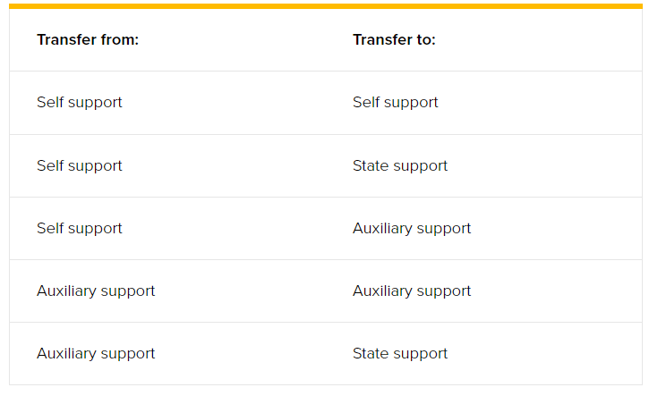

Contact Information
Phone/Email Contacts
Original Budgets – For questions related to your original budget, contact your Divisional Budget Officer.
Revised Budget – For questions related to revisions made to your budget, including transfers, contact the University Budget Office at x4-2182 or UBO@towson.edu.
Budget Monitor – For questions refer to the training materials provided on the Budget Office website: budgetoffice/Stratus.html. If you still have questions, contact the University Budget Office at UBO@towson.edu.
For more information on budgets, including Towson University’s Operating Budget and Plan, visit the University Budget Office Web site at:
http://www.towson.edu/budgetoffice/index.html

Capitalized – Assets that are tangible and cannot be easily converted to cash; held for a long period of time; depreciable; typically are over $250,000. Examples – new buildings, major renovations; equipment purchases for a new building. Usually reserved for Facilities Management Projects.

