Guidelines and Resources for TU Pre-Physician Assistant Students
Citation for these guidelines: “Texel, S., S. Evans and L.S. Johnson. [document date]. Advice and Guidelines for TU Pre-Physician Assistant Students. Unpublished document accessed from the following website: [insert URL here].

What is a PHYSICIAN ASSISTANT and what education IS REQUIRED?
A PA is a trained and licensed health care professional that works under the guidance and mentorship of a physician in the practice of medical care. Training is very broad so that the PA can enter not only general practice but a variety of different medical specialties including surgery.¹ Most PA programs are 2-year Master’s degree programs. The first year is focused on course work and the second year on clinical rotations.¹ The training is significantly shorter than medical school and thus requires students to come in with a large amount of health care experience (see requirements below). Here is a link to a video summarizing the profession: https://www.youtube.com/watch?v=eBTcpA7kmIU

Requirements FOR PA SCHOOL AND RECOMMENDATIONS
As the PA profession has become more popular, the number of PA programs has been increasing quickly. Each program has slightly different admission requirements. A list of all the PA programs in the US can be found at the physician assistant education association website (http://directory.paeaonline.org/) along with some general program and accreditation information. For specific program requirements you should visit the website for the university or college offering the program.
Course Recommendations For TU Pre-PA Students
Pre-PA students can choose either the Functional Biology of Animals concentration or the Cellular and Molecular Biology concentration and do the following:
- For the physiology requirement, take BIOL 221/221L+222/222L-Human Anatomy & Physiology I and II or BIOL 342/343- Human Physiology I and II (depending on catalog year).
- Taking the one-semester organic chemistry course, CHEM 330, will meet most PA program requirements
- For one of the elective courses, take BIOL 318-General Microbiology
(Note that Biol 215-Essentials of Microbiology is acceptable for PA programs but does not count towards
the Biology major or provide upper level credit)
- For your “free elective” course, take CHEM 351-Biochemistry (check also whether any of the PA programs you might apply to required Biochemistry lab… if so, take CHEM 356)
- For your math requirement, take MATH 237 (students transferring in MATH 231-Basic Statistics, from elsewhere or from a previous major at TU may substitute it for MATH 237, however students should check with the programs they are interested in applying to. Some programs require the statistics class to cover ANOVA/variance analysis, which is not covered in MATH 231.)

The following courses are not necessarily required for a Biology degree but are required by most PA programs:
- Most PA programs require at least 3 credits in psychology (some require even more). It is recommended all pre-PA students take PSYC 101 or 102 (Core 6). If additional psychology classes are needed, take PSYC 203-Human Development, and/or PSYC 361-Abnormal Psychology.
- Most PA programs required a 3-credit course in medical terminology. At TU you can take BIOL 210-Medical Terminology or KNES 215-Medical Terminology, or you can elect to take a 3-credit medical terminology course at a community college.

For Core 9, an ENGL course is strongly recommended. Options include:
- ENGL 310: Writing Argument
- ENGL 313: The Academic Essay
- ENGL 318: Advanced Informational Writing

Health Care Experience
In addition to the undergraduate coursework required for PA school, you will need to gain a significant amount of health care experience or what some programs call “patient contact” experience. The total number of hours required varies from program to program but is generally in the range of 800-1600 hours. The type and quality of these hours also matters. Programs prefer experiences in which the applicant was directly responsible for patient care. Many programs provide applicants with lists of the type of experiences that they prefer applicants to have. Examples of these lists from the Towson University and Anne Arundel Community College programs are found at the end of this document. Note that hours spent shadowing a physician or physician assistant are considered low-quality hours and may not be considered at all by some programs.
Getting quality health care experience hours – the dilemma and potential solutions
Many pre-PA undergraduates face the same dilemma: They need quality health care experience hours but they are so busy during each semester with courses, a job to pay bills, and other activities, that they just don’t have the time to get much health care experience. So what to do?
One option is to set aside summers (and perhaps late December and the minimester) to get experience. Not everyone, however, will have the option of devoting summers to this activity, and it is harder to get “quality” types of experience when you are only available for a relatively short time.
A second option then is to take a year or two immediately after graduation to get the hours one needs. Ideally, one would try to get a job that would simultaneously provide both quality health care experience hours and some income. Such jobs would include things like nursing aide, physical therapy aide, phlebotomist, etc. (again, see list of possible jobs at the end of this document). Be aware, however, that some training will almost certainly be required before you can step into one of these jobs. In many cases, you can get this training over the course of a summer or semester at a community college.
Yes, this second strategy will delay your entry into PA school. However, there are several upsides. First, it will likely increase your chances of getting into a program because you will have racked up a larger number of quality health care experience hours. Second, this may allow you to save some money, which can be used to pay bills during the two years you are in PA school. All in all, you need to remember that, 20 years from now, a delay of a year or two will be long forgotten if you have been happily working in the career of your dreams.

The Graduate Record Exam (GRE)
Most PA programs require applicants to take the GRE General Test. Normally the Medical College Admission Test (MCAT) is not accepted in place of the GRE. More information on the GRE can be found at: https://www.ets.org/gre/revised_general/about.

ADMISSION TO PA SCHOOL IS VERY COMPETITIVE
The number of PA programs is increasing, however, the interest in PA school is also increasing and competition for admission remains intense. The number of slots available in most PA programs each year is relatively small. It is widely thought that if a student can’t get into medical school, they can still fairly easily get into PA school. This is not true; admission to PA school is just as – if not more – competitive than admission to medical school.
To be a competitive applicant you will want to maintain at least a 3.5 GPA. Note that most programs have a minimum GPA requirement and will not even review applications if this minimum is not met. In addition to your overall GPA, your science GPA, (that is calculated from just your science courses) is also evaluated and some programs have a minimum science GPA requirement.
In addition to your GPA, the other important factor in your application is the amount of health care experience you have. You want to make sure you have at least the minimum contact hours required by the program you are applying to, though most competitive applicants will have quite a bit more than the minimum. You can generally consider the range provided by programs (e.g., 800-1600 hours) as the span from the minimum acceptable (800) up to the preferred number of hours (1600). As noted above, the quality of those contact hours is also important. The more directly you are responsible for the care of patients, the more valued that experience will be considered.
The specific requirements for GPA and health care experience hours can usually be found on the program’s website. Here is a link to the Towson University’s PA program Information and Admissions booklet: http://grad.towson.edu/program/master/past-ms/files/2015PAProgramInfoBooklet.pdf

APPLICATION PROCESS AND DATES
Most PA schools use the Central Application Service for Physician Assistants (CASPA). More information on the benefit and purpose of CASPA can be found at the following link: http://www2.paeaonline.org/index.php?ht=d/sp/i/141513/pid/141513
The application cycle generally opens in mid-April the year before the start of the program. Pay close attention to application deadlines. These deadlines vary from program to program and generally fall between the September and January prior to the program’s start date. Some programs have rolling admissions, which means they begin reviewing applications as they arrive and once all of the seats have been filled they stop accepting applications even if the deadline has not yet been reached, so there is an advantage to applying as early in the cycle as possible.
Completing the B.S. degree before applying
PA programs in Maryland require students to have completed their Bachelor’s degree prior to applying. Because of this, students will have a “gap” year between finishing their B.S. and attending PA school. It is often wise to spend that year boosting the number of quality hours spent in patient care in case you do not gain entry into a PA program on your first try.
This requirement does not apply to all (or most) programs outside of Maryland, which means you can apply to non-Maryland PA schools in your junior year if you have sufficient health care experience hours.
WHAT IF YOU DON’T GET INTO PA SCHOOL ON THE FIRST TRY?
If you are not admitted to PA school on your first attempt, and you want to re-apply the next year, you will want to strengthen your application. You should continue to gain quality health care experience.
You can also continue your education. One option is to attend graduate school in Biology or Health Science. This will expand your background knowledge and will demonstrate that you can be successful with graduate-level coursework.
If your GPA is not strong you may want to consider an alternate career choice. There are a tremendous number of interesting careers available in human health care.

USEFUL WEBLINKS
Towson University’s Pre-PA Club: https://involved.towson.edu/organization/PrePa
CASPA: https://caspa.liaisoncas.com/applicant-ux/#/login
American Academy of PAs: https://www.aapa.org/
Physician Assistant Education Association: http://www.paeaonline.org/
Accreditation Review Commission on Education for the PA, Inc.: http://www.arc-pa.org/
PA student blog with helpful information on health care experience hours: http://doseofpa.blogspot.com/2014/02/health-care-experience-and-pa-school.html

REFERENCES
¹ Rodican, A., & Rodican, A. (2011). The ultimate guide to getting into physician assistant school (3rd ed.). New York: McGraw-Hill Medical.
Towson University List of Potential Patient Contact/Health Care Experiences
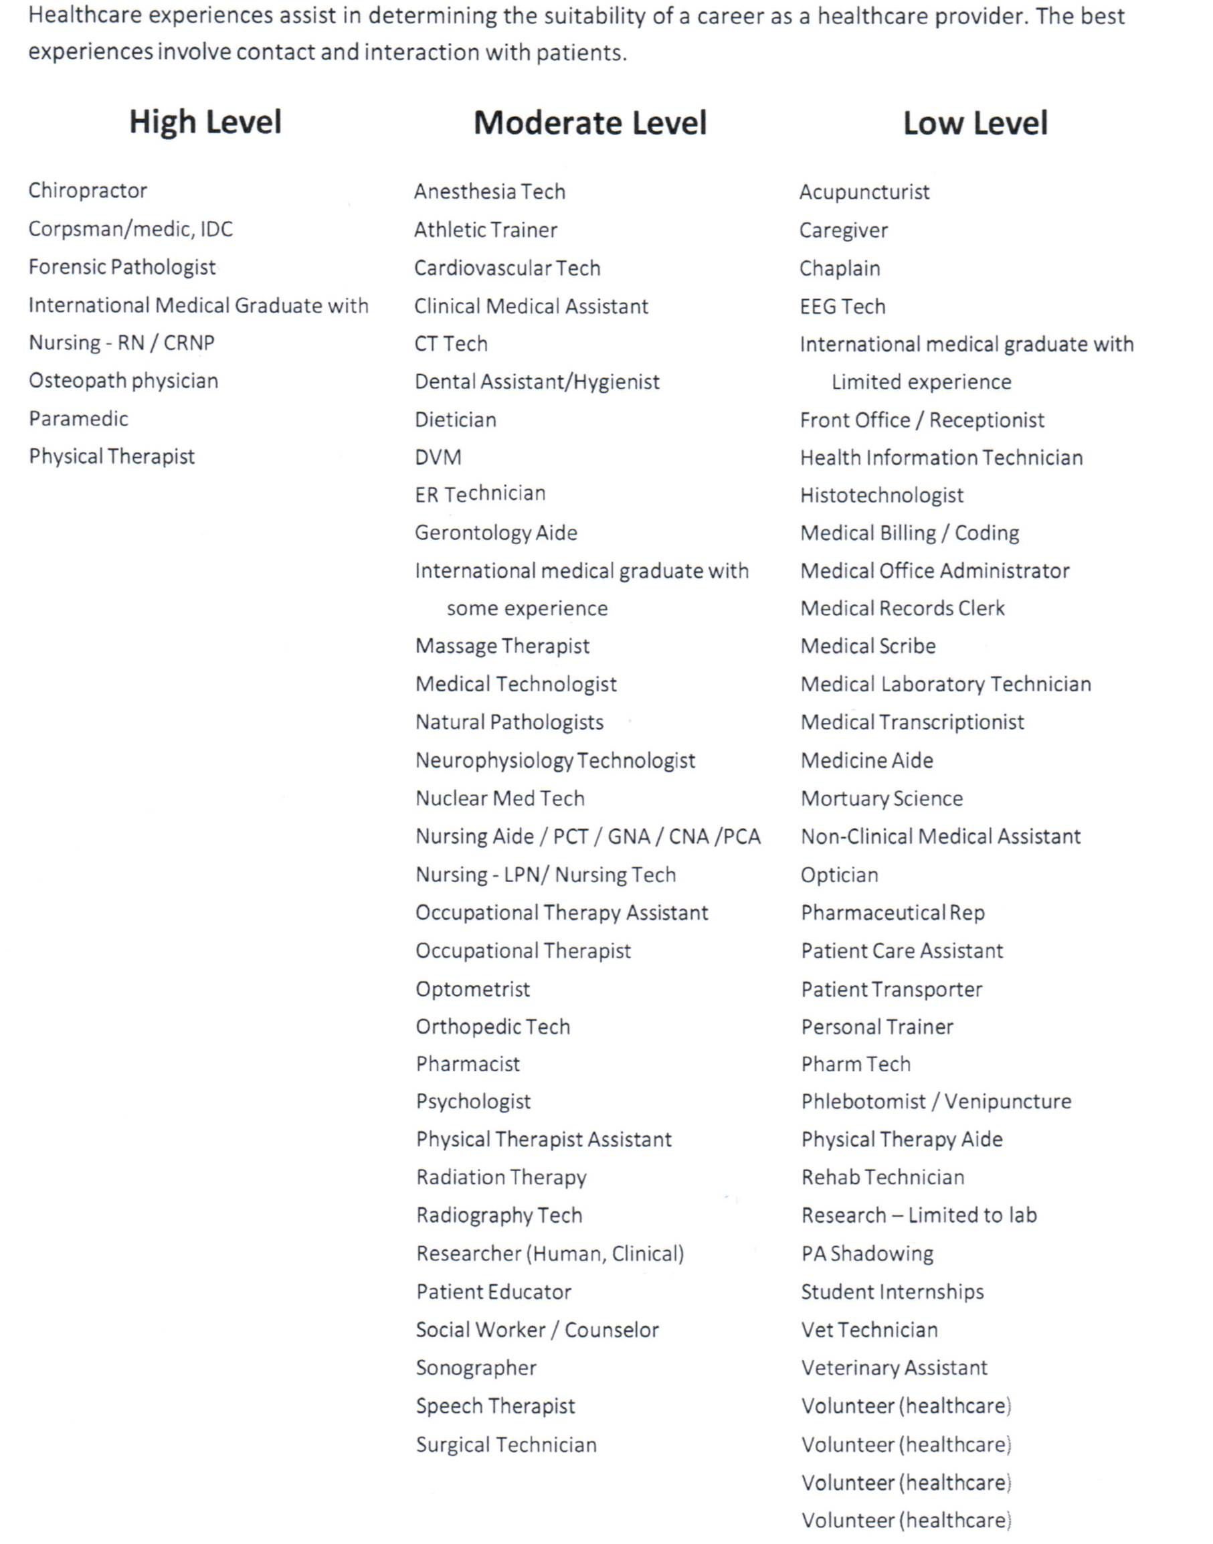

Anne Arundel Community College’s List of Acceptable and Unacceptable Patient Contact/Health Care Experiences

