Online enrollment with Selerix is simple, secure and can be done in a few minutes from any computer with internet access. After enrolling online, you will have access to view your benefit information 24 hours a day, from any computer.
What you need to get started…

During the enrollment process you will be asked to provide some basic information that you should have available.
- Your social security number
- Your dependent’s social security numbers and birth dates
Welcome Page

After your initial login, the system will take you to the Welcome Page. From this screen, you should follow the navigation using the Next buttons. The Your Benefit Options box to the right includes the benefit enrollments screens that will appear during the enrollment process.
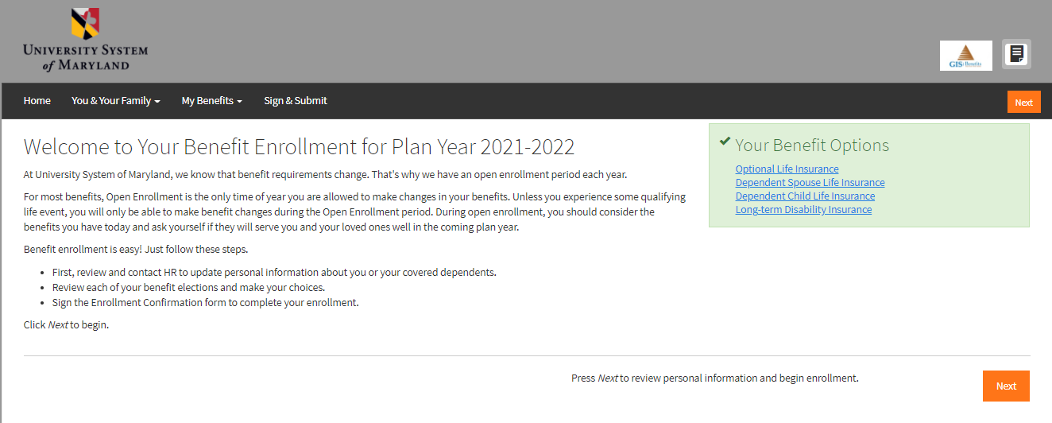

Personal Information

The system will now take you to the PERSONAL INFORMATION section:
- Make any changes to Personal Info, such as Address, Phone Number, or Email.
  - Please be sure you communicate those changes back to HR, as this system does not feed back to your personnel file.

When you are finished, click Next to save and move to the next screen.

Dependents

Next, the system will take you to the DEPENDENT Section. On this screen, you can add any dependents if they are not listed.

- To add a dependent, click on the + sign to open the Add Dependent Screen
- Complete the required fields.
- If any of your dependent data is not current or accurate, you may click the pencil on the right-hand side next to their name and edit.
- Note: the address will auto-populate to the Employee’s address.
- Click Save when complete.

Enrolling in Benefits

The system will now start to navigate through the benefit election screens, in the order in which they appear on the Welcome Screen. Apply or Decline the benefits on each screen, selecting the coverage tier that you wish to apply for within that benefit.

- Some screens may have a slider bar to allow you to choose a benefit level.
  - NOTE: This slider-bar will turn RED when you select an amount above the Guaranteed Issue amount, and the amount selected will be subject to underwriting.
- Beneficiary information will be required for your Optional life plans.
- Green checks indicate benefits that you have enrolled in.
- Red checks indicate benefits that you declined.

Completing Your Enrollment

Once you have gone through enrollment for each plan available, the system will take you to the Sign and Submit page. This screen will show you a summary of the information you entered and the benefit elections you made. Currently, if you want to make any changes, click on the underlined benefit to navigate back to that benefit screen.

- To complete the enrollment process, click next.
- Review/Sign Forms that open next – using your login password as the signature PIN.
- If you need to log off before completing enrollment, any data you entered will be saved.
- Enrollment is completed when you see the CONGRATULATIONS! On the Sign/Submit Complete screen.
- Always make sure to log out upon completion.
- If you have any questions on navigating the enrollment site, please reach out to letushelpyou@gisbenefits.net for assistance.
  - When reaching out please include your full name and that you are an employee of USM
- Completing Your Enrollment
Tips

- This portal is only showing the new MetLife benefits, which took over the Unum life and disability plans, you will not see any state benefit plan on this site.
- Best experience is had when following the above instructions and using the orange “Next” buttons in the lower right-hand portion of the screen. Trying to navigate benefits using the search bar at the top will result in inaccurate or difficulties in viewing the new payroll deduction amounts with MetLife.
- If you had prior coverage with UNUM, this would show as you move through the enrollment experience, to maintain your UNUM plan click Apply then Next.
  - Your UNUM plans will be carried over to MetLife if you do not formally waive them using the enrollment site.
- In the upper right-hand portion of the screen, you will see a paper icon, you can click there for all benefit explanation documents from MetLife to show the new plan design.
- The online Statement of Health is at the very end of the enrollment process (screen shot below), please click the “Statement of Health” button to be routed to MetLife to complete their form.
  - It is important to note, GIS does not have visibility on reasons for a carrier’s Statement of Health decisions (approvals and denials), these conversations are best had with the carrier, as questions address sensitive PHI.
